LESSON 4: OUTDOOR WATER CONSERVATION

Name______________________________
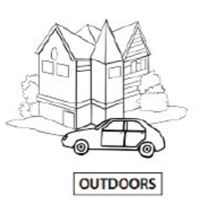
Warm Up Activity
What are some ways that you use water outdoors at home or school? Write down as many ideas as you can!

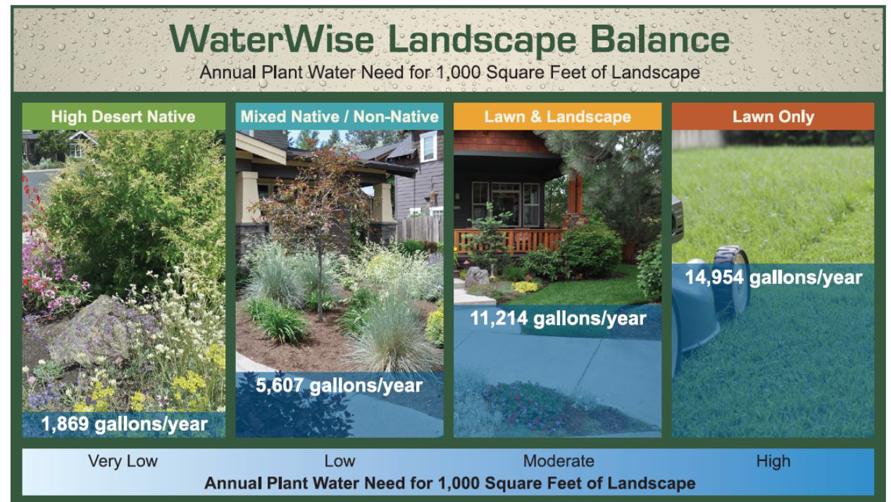

= High Water Use Area  = Low Water Use Area | = Efficient Water Use Practices  = Areas for Improvement
Map Your Schoolyard
In this activity, you will survey the land covers at your school and investigate outdoor water use to explore the current conditions impacting your local watershed.
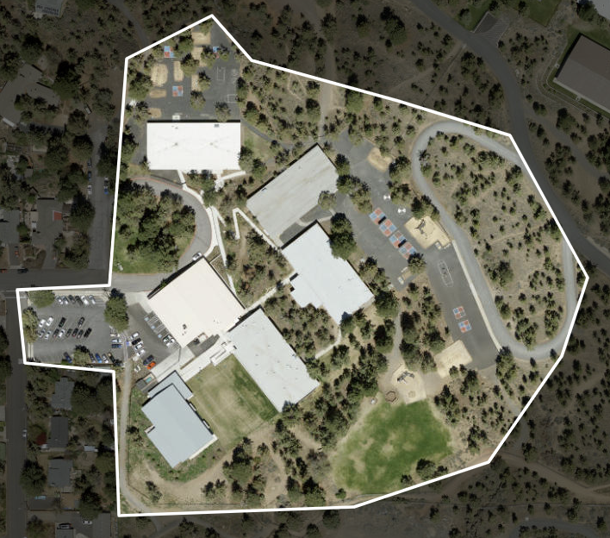

KEY:

Exit Ticket

- What is one way that using water outdoors can impact our watershed?

- Circle one: During which season is water usage highest outside?
  - Spring
  - Summer
  - Fall

- Circle one: Which landscaping choice uses the least amount of water?
  - Native plants
  - Lawns
  - Mixed lawn and landscape

- Finish the sentence: One new way I can conserve water outside is...

