LESSON 3: INDOOR WATER CONSERVATION

Name______________________________
Warm Up Activity
What are some ways that you use water indoors at your home or school? Write down as many ideas as you can!
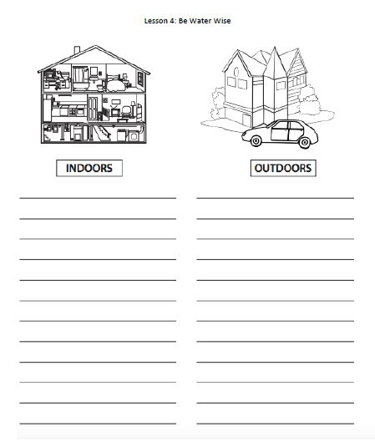

Home Water Usage
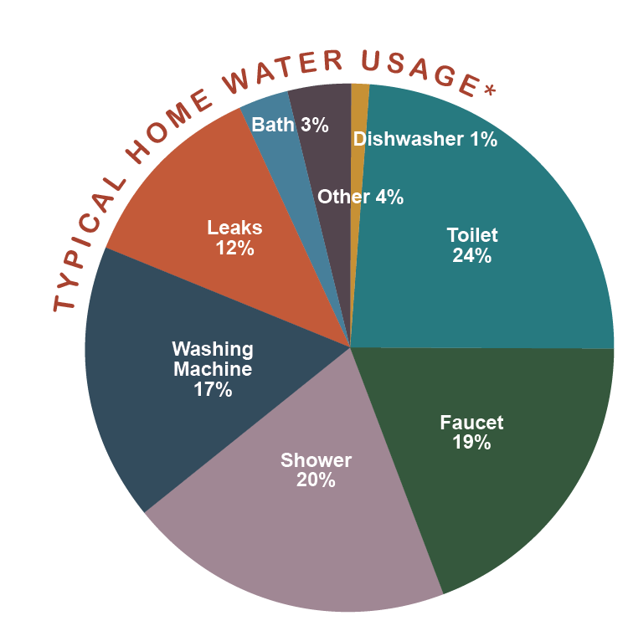
How do most people in Bend use their water indoors? Test your knowledge by filling in the words in each box from the word bank below!

WORD BANK

Toilet Washing Machine Leaks Shower Faucet

Waterwise Challenge: Toilets

1. Your bed and breakfast has a toilet that uses water at 3.5 gallons per flush. A customer at the bed and breakfast flushes the toilet 7 times a day. How many gallons are being used every day per person from flushing the toilet?

________________ x ____________ = _________________
Gallons per flush Times a day Gallons used per day

2. If the average customer uses the toilet every day of the year (365 days), how much water does your business use in a year? Use the answer from above to help figure out this answer!

________ x ___________________ = _________________
Days Gallons used per day Gallons used per year!

3. Your business switched its toilet for a WaterWise one that flows at around 1 gallon per flush. The average customer still flushes the toilet around 7 times a day. Let’s now calculate how much water they use!

_________________ x ____________ = _________________
Gallons per flush Times a day Gallons used per day

4. How many gallons would they now use per year (365 days) with the new toilet? Use the answer from above to figure this out!

______ x ___________________ = _________________
Days Gallons used per day Gallons used per year!

WaterWise Challenge: Showers
- The average customer at your bed and breakfast takes a shower for 10 minutes. Your showers have an old showerhead that uses 2.5 gallons per minute of water. How many gallons of water does that one person use?

_______ x _________________ = ____________________
Minutes Gallons per minute Gallons used per shower

- If the average customer takes a 10-minute shower every day of the year (365 days), how much water does your business use in a year for showers? Use the answer from above to help figure out this answer!

_____________ x _____________________= _________________
Days in a year Gallons used per shower Gallons used per year!

- Your business switched to a WaterWise showerhead that flows at 1.5 gallons per minute. Your customer still takes 10-minute showers. How many gallons of water do they now use per day for a shower?

________________ x _______ = ____________________
Gallons per minute Minutes Gallons used per shower

- If one customer takes a shower every day of the year (365 days), how much water does your business now use in a year? Use the answer from above to help figure out this answer!

_______________ x _____________________= _________________
Days in a year Gallons used per shower Gallons used per year!

WaterWise Challenge: Faucets

- The average customer at your bed and breakfast keeps the faucet on for 3.5 minutes while washing their hands throughout the day. The sink faucet flows at 2 gallons per minute. How many gallons of water do they use for handwashing in a day?

________ x _________________ = ___________________
Minutes Gallons per minute Gallons used per day

- If the average customer keeps the faucet on for this long every day of the year (365 days), how much water does your business use in a year? Use the answer from above to help figure out this answer!

_____________ x __________________= _________________
Days in a year Gallons used per day Gallons used per year!

- Your business switched its old faucet for a WaterWise one that flows at 1 gallon per minute. Your customer keeps the water on for 3.5 minutes per day while washing their hands. Let’s now calculate how much water they use!

________________ x ________ = __________________
Gallons per minute Minutes Gallons used per day

- If the average customer keeps the faucet on for this long every day of the year (365 days), how much water does your business use in a year? Use the answer from above to help figure out this answer!

_____________ x __________________= _________________
Days in a year Gallons used per day Gallons used per year!

Exit Ticket

- Circle one: Where is water used the most in our homes, schools, or businesses?

  - Showers
  - Toilets
  - Faucets
  - Dishwasher
- Circle one: Fresh water is a limited resource on our earth.

  - True
  - False
  - Not Sure
- Finish the sentence: One way I can conserve water is...

