LESSON 2: THE PATH OF WATER

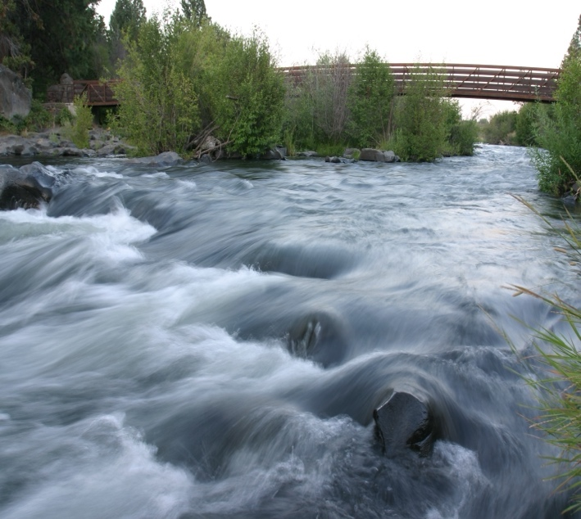

Overview
In this lesson, students will become familiar with our local municipal watershed and the path of water to the City of Bend by taking a virtual tour of it and exploring our various water utility resources. Through these explorations, students will examine how water cycles through our watershed as a part of the hydrologic cycle and how understanding the path of water in their community can impact and influence their use of this natural resource and the health of our water.
Lesson Length:
60 Minutes

DESIRED RESULTS
Essential Questions
- What is a watershed, and how does water move throughout it?
- Where does our drinking water come from, and how can knowing this information impact how we use it?

Learning Outcomes
Students will know:
- What a watershed is.
- Where our drinking water in Bend originates and some of the utility resources we have in our community to help us utilize this water.
- How water cycles through our watershed as a part of the hydrologic cycle and our utility resources.
- Humans live within a watershed ecosystem and utilize its resources.

Learning Targets for Students
- I can identify the source of our drinking water in Bend.
- I can explain how water moves throughout our watershed through our utility resources and as a part of the water cycle.
- I can communicate how humans live within a watershed and use its resources.

ASSOCIATED STANDARDS
Next Generation Science Standards
5-ESS3-1: Obtain and combine information about ways individual communities use science ideas to protect the Earth’s resources and environment.

Oregon Social Sciences Standards
5.12: Describe how technological developments, societal decisions, and personal practices affects sustainability in the United States.

Oregon English Language Art Standards
5.W.9: Draw evidence from literary or informational texts to support analysis, reflection, and research.

5.SL.1: Engage effectively in a range of collaborative discussions (one-on-one, in groups, and teacher-led) with diverse partners on grade 5 topics and texts, building on others’ ideas and expressing their own clearly.

LESSON MATERIALS  - The Path of Water slide deck  - Student journals  - Printer paper (1/group)  - Water-based markers (shades of blue)  - Spray bottles (1/group)  - Small aluminum pan (1/group)  - Sponge (1/group)  - Pencils  - Projector  - Bend Municipal Watershed Tour  - QR Code of watershed tour  - Optional: Student tablets/computers | ASSESSMENTS  Formative:  - Teacher observations  - Small group discussions  - Journal questions  - Exit ticket reflection

VOCABULARY
- Aquifer
A body of permeable rock that can contain or transmit groundwater.
- Groundwater
Water located beneath the ground that fills empty spaces like cracks and spaces in soil, sand, and rock. It is stored in and moves slowly through geologic formations of soil, sand, and rocks called aquifers.
- Municipal
Referring to a city or town with its own local government, or the local government itself.
- Runoff
Rain or snow/ice melt that does not soak into the ground becomes runoff and can carry soil, pollutants, and other materials from the land into our river or toward our underground water supplies.
- Springs
A place where water moving underground finds an opening to the land surface and emerges, sometimes as just a trickle, maybe only after a rain, and sometimes in a continuous flow.
- Surface Water
Water that collects above ground, including streams, rivers, lakes, wetlands, reservoirs, creeks and oceans.
- Watershed
An area of land that drains water, over land or underground, to the same place, such as a stream, river, or even the ocean. Each watershed is determined by its topographic boundaries. Gravity ensures water flows from high point to low point. Some watersheds are small, and some are big.

PRE-LESSON PREPARATION:
- Prior to this lesson, check in with the teacher to see if their students all have one-to-one tablet or laptop devices. If they do, take time prior to the lesson to ensure that the virtual tour works on their devices. If it is saying the student does not have access to the tour, have them sign out of their Google accounts and try again. Alternatively, you can show this tour on the projector with the whole class (though it’s more engaging on individual devices!).

ENGAGE
Time: 10 Minutes
- Slide 1 – Warm-Up Activity
  - As students enter the classroom, provide them with their journals and direct them to the warm-up prompt: How do you think our drinking water gets to our community in Bend? Draw or write your ideas in your journal!
  - Students can work independently or with a partner nearby and encourage them to write down as many steps as they can in this process.
- Slides 2-3 – Learning Objectives and Essential Questions
  - Once students have completed the warm-up, introduce the program once again and review our essential questions for the day:
    - What is a watershed, and how does water move through it?
    - What is the source of our water?
    - How does understanding where are water comes from influence the way we use and protect it?
EXPLORE
TIME: 20 Minutes
- Slide 4-6– Maitre D’
  - Before diving into our warmup, remind students that we are all a part of the watershed and are considered “watershed users” based on the different ways we make use of water in our everyday lives. Share that the way that water gets to our community is known as the “path of water”.
  - Reiterate our warmup question to students: How do you think our drinking water gets to our community in Bend? Prior to sharing their answers out loud, have students share their drawings and ideas with a partner using the Maitre d’ activity from lesson 1. Students will mingle around the room and find a partner to discuss their warmup.
  - Prior to sharing their warmup, have students mingle once more about the classroom and find a partner to answer the following question: How is the water cycle a part of this process?
- Slides 7-8 - The Water Cycle in our Watershed
  - After sharing their ideas, explain to students how the water cycle plays an incredibly important role in how water moves throughout our watershed.
  - Show slide 7 and sing the water cycle song and dance as a class:
    - Water travels in a cycle yes it does, water travels in a cycle yes it does. It goes up as EVAPORATION, comes together as CONDENSTATION, falls down as PRECIPITATION, yes it does! RUNOFF!
- Explain that the water cycle is essential to understanding how a watershed works
  - Review the definition of a watershed on Slide 8
- To further understand this concept, have students build their own watershed
  - Break students up into groups and provide each with a piece of printer paper, water-based markers, a small aluminum pan, and a sponge.
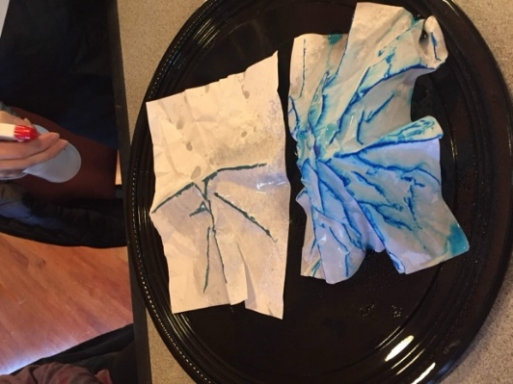
  - Have students crumble up the piece of paper and then smooth it back out most of the way. The paper should be a bit crumpled up still but have lots of high and low points which will represent the ridge tops and valleys.
  - Use the blue marker and draw along the ridgetops of the model. Once completed, place the sponge and paper in the pan.
  - Provide each group with a spray bottle.
    - Have students spray their watershed model and ask what step of the water cycle this is (precipitation).
    - Where do they think the water will travel? Ask students to make observations about where the water travels.
    - Where did their water go, and how did the high and low points of their paper affect where it traveled? As students are reflecting upon these questions, explain how when water is running down the surface of the land, we call this runoff which will ultimately accumulate in the surface water they see pooling on their aluminum pan.
    - Ask students what they think the sponge represents. What happened to the sponge? They will likely notice it absorbed some of the water that did not become rivers/lakes.
    - Explain to students that much of our land in Central Oregon has sponge-like volcanic rocks and that much of our water percolates into the Earth as groundwater. This water is like an underground river and that at times emerges onto the surface of the land as springs that help to refill our surface water.
  - If time, have students do another watershed model, but add sources of pollution like cities and farms. Repeat the activity and ask them where the pollution is going. What do they notice about the water?
    - Explain that we will dive deeper into this topic of runoff/pollution in later lessons
- Slides 9-10 – Watershed Overview
  - By having this understanding of how water cycles through our watershed, students can now begin to explore some specific features of our local watersheds. Remind students of the name of the watershed where we get our drinking water, the Bend Municipal Watershed.
  - To help students get familiar with this watershed, show them the map on slide 9 and 10 the reaches of this area and in their journal.
  - Using slide 10, explain how the high and low points they saw on their watershed model play a role in creating separate watersheds. Have students consider what would happen if water went down the back side of their watershed model and ultimately explain that the water flowing there would be a part of a separate watershed! If time permits, ask them if they recognize any of the nearby landmarks on the map, such as the mountains, that help to create this boundary of the watershed.
- Slides 11-14 – Surface Water and Groundwater
  - Remind students that our drinking water in the Bend Municipal Watershed comes from surface water in Bridge Creek, but that water actually begins as groundwater!
  - Surface water and groundwater are interconnected. Ask students what they remember about surface water and groundwater from our first lesson and how each of these water sources gets fed.
  - Show students the picture on slide 11 and share with them that our drinking water source in Bend is the surface water that comes from Bridge Creek. Remind students that surface water is water that collects above ground, including streams, rivers, lakes, wetlands, reservoirs, creeks, and oceans and that rain or snow/ice melt that does not soak into the ground becomes surface water runoff.
  - Using slide 12, explain to students that while our drinking water in Bend comes from surface water, Bridge Creek originates because of groundwater! Share that the springs that feed Bridge Creek, Prowell Springs, emerge from an opening in the ground and help to create the stream that gives us our drinking water.
  - Show students the picture of our regional aquifer on slide 13. Remind students that while some water from our rain or snow/ice melt will be surface water runoff, some of this water will percolate into the ground as groundwater. Review that groundwater is water located beneath the ground that fills empty spaces like cracks and spaces in soil, sand, and rock and that it is stored in and moves slowly through geologic formations of soil, sand, and rocks called aquifers. The aquifer not only feeds the surface water at Bridge Creek, but our City sometimes gets water by digging wells into the aquifer.
- Slide 14 - City of Bend Facilities
  - Explain to students that as water moves through our community as surface water or groundwater, it interacts with many of the City of Bend utility resources and facilities to help deliver water to our community and return it back to the watershed. Show students slide 14 and explain that we will later go over many of the areas circled through a tour of our watershed in our next activity!

EXPLAIN/ELABORATE
TIME: 20 Minutes
- Slide 16 – Bend Municipal Watershed Tour
  - Following this watershed overview, ask students why they think it might be important to understand the path of water, or how water moves, throughout our community.
  - After they answer, explain how humans rely on the water in our watershed for many things and knowing how it gets to our community (and the time it takes to get there!) can help us be aware of how to take care of this important resource. By knowing the path of water and how it moves throughout our watershed, we can be mindful of the way use and interact with it as a watershed user to help maintain its health for all of its users who rely upon it.
  - Share with students that to get to know the path of water through their community in more detail they will take a virtual tour using the Bend Municipal Watershed Tour!
  - In this tour, students will follow a water droplet on its journey through the watershed and many of the City of Bend’s water utility resources and facilities. This tour can either be accessed virtually on students’ individual digital devices using the QR code, or viewed as a class. (Note: students must click “use without an account” to have access to the tour. Or they need to sign out of their google account)
  - Using slide 15, show students how to navigate through this tour if they are doing so on their own devices. As students are on their virtual tour, they will be asked to match the location in the word bank with each numbered stop on page 2 of their journal!
  - If students finish early, have them begin on their exit tickets.

EVALUATE
TIME: 10 Minutes
- Slides 16-17 – Lesson Conclusion and Next Lesson Objectives
  - Once students have completed the tour, gather students back up to reflect upon their learning from the day and review all of the stops they took along the way. Explain the purpose of each stop of the tour so that students can accurately understand the role each one plays in our municipal watershed’s path of water.
  - Following this reflection, review the essential questions from the beginning of our lesson to conclude our lesson. Spend some time discussing with students why knowing about the path of water in our community might influence how we use our water.
  - To prepare students for our next lesson, share with them the topic of our next lesson on slide 17.
- Exit Ticket Instructions and Cleanup Procedures
  - To evaluate learning from the day, have students complete the Exit Ticket in their journal as a formative assessment for future lessons. Review the instructions for how to complete it with students and share any cleanup procedures following the completion of their assessment.

Extension Ideas
- Learn more about the interconnectedness of the watershed by watching Why Should You Care About Our Watersheds?.
- Curious about the headwaters and path of water through the Upper Deschutes River watershed? Watch the Did You Know? The Headwaters video!
- Explore the path of water through the Upper Deschutes River watershed by completing the Upper Deschutes Watershed: Your Ecological Address activity.
- Help your students learn more about the water cycle by viewing the Water and You: The Water Cycle video.
- To further students’ understanding of the role of groundwater, have them watch the What is Groundwater? video.
- Have students draw a model of the path of water through Bend. Include and label any of the parts from our Bend Municipal Watershed Tour activity that students completed as a part of the lesson.

Additional Resources
Books
- Conserve Water – Educators Guide. The Watercourse, Montana State University, Montana, 2000.
- Project WET Curriculum and Activity Guide 2. 0. Project WET Team, 2011.
- The Complete Guide to Service Learning: Proven, Practical Ways to Engage Students in Civic Responsibility, Academic Curriculum, & Social Action. Cathyrn Berger Kaye, 2010.
- Leadership 101: Developing Leadership Skills for Resilient Youth Facilitator's Guide, Mariam G. Macgregor, 2000.
- Mentoring for Meaningful Results: Asset-Building Tips, Tools, and Activities for Youth and Adults. Kristie Probst, 2006
- Exploring Water with Young Children. Ingrid Chalufour and Karen Worth, 2005.

Websites
- American Water Works Association - http://www.awwa.org/waterwiser/
- Project WET - http://www.projectwetusa.org/
- The Groundwater Foundation - http://www.groundwater.org/
- River Rangers Tool Kit - https://www.startwithabook.org/sites/default/files/river-rangers-toolkit-national.pdf

Local Resources
- The City of Bend Utility Department - https://www.bendoregon.gov/government/departments/utilities
- Upper Deschutes Watershed Council – https://www.upperdeschuteswatershedcouncil.org, 541-382-6103
- Trout Unlimited - https://www.tu.org
- Deschutes River Conservancy - https://www.deschutesriver.org

