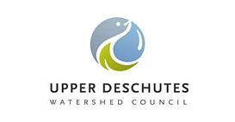
Camp Polk Groundwater Data Analysis Activity

Groundwater is an important resource in Central Oregon. Our rivers, lakes, and wetlands depend on the recharge from groundwater aquifers to stay full through the dry summer months. But what is groundwater?

- Groundwater is the water found underground in the cracks and spaces in soil, sand and rock. It is stored in and moves slowly through geologic formations of soil, sand and rocks called aquifers.
- Groundwater supplies drinking water for 51% of the total U.S. population and 99% of the rural population.
- Groundwater helps grow our food. 64% of groundwater is used for irrigation to grow crops.

Camp Polk Meadow Preserve was protected by the Deschutes Land Trust in 2000. The 151 acre preserve is located near Sisters, Oregon. The Preserve contains approximately 1.4 miles of Whychus Creek with wetlands, meadows, aspen groves and ponderosa pine stands.
In May of 2007, the UDWC installed seven monitoring wells in Camp Polk Meadow. The wells were installed in two cross sections, consisting of two and five wells. The location for the five-well cross section was selected because it is in the middle of the meadow and at the widest section of the meadow and is influenced by spring water flows from the northwest end of the meadow.
In February 2012, a restoration project of Camp Polk Meadow was completed, and Whychus Creek was diverted into the restored meadow channel. The return of the creek to its historic meandering flow was thought to elevate the groundwater level in the meadow.
We calculate the monthly median depth to groundwater for the seven wells collectively to show how groundwater levels change in the meadow throughout the growing season.
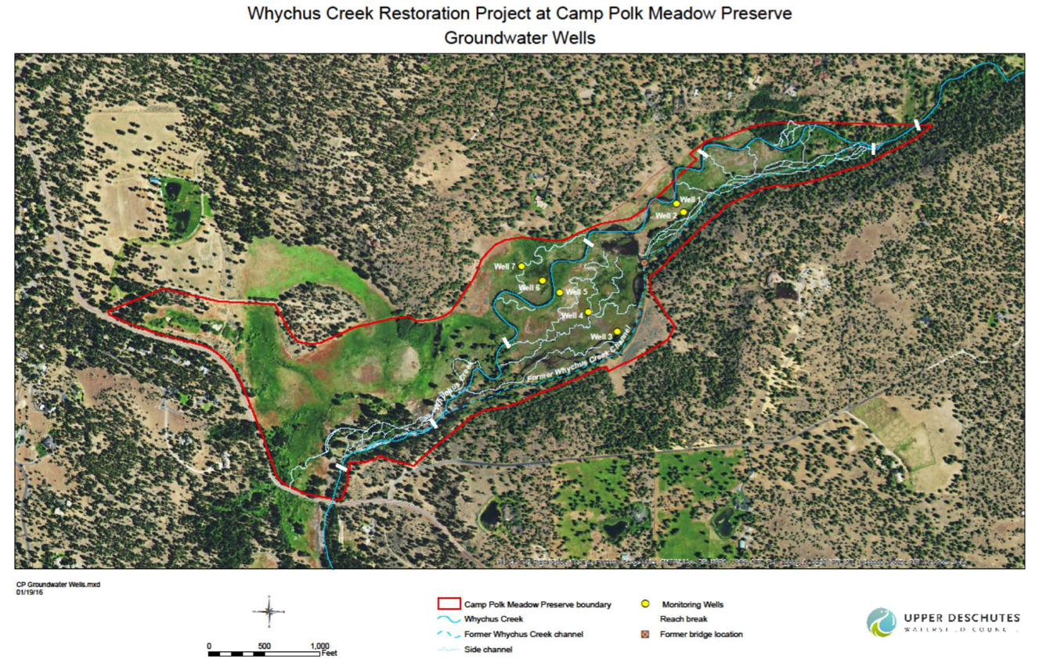

Step 1: Watch the video of Lauren Mork, Program Manager for the Upper Deschutes Watershed Council, explain groundwater in Camp Polk Preserve. Follow along and answer these questions as you watch:
https://www.youtube.com/watch?v=mQ8tMyYSd0A

What were three goals of the restoration project?

Why is groundwater important?

What groundwater level or depth do plants need to survive?

What is the name of the instrument that measures water depth and how do you use it?

Why do you think it is important to take the measurement twice?

Step 2: Below is the median monthly data from 2008-2017 for the growing season months (April-October) for Camp Polk. Create a simple line chart to show the change in the ground water level for each month over the 9-year period.

Camp Polk Groundwater Monthly Medians for Growing Season
 | April | May | June | July | August | September | October
2008 | 3.00 | 3.84 | 4.10 | 4.96 | 6.04 | 6.38 | 6.57
2009 | 4.94 | 4.89 | 5.08 | 4.32 | 4.62 | 4.63 | 4.36
2010 | 3.51 | 3.59 | 3.97 | 4.14 | 4.32 | 4.42 | 4.28
2011 | 3.02 | 3.38 | 3.42 | 3.65 | 3.88 | 3.99 | 3.98
2012 | 2.22 | 2.15 | 2.13 | 1.54 | 1.89 | 2.44 | 2.87
2013 | 2.18 | 2.36 | 2.41 | 2.54 | 3.49 | 3.65 | 3.20
2014 | 1.63 | 2.02 | 2.14 | 2.28 | 2.38 | 2.43 | 2.42
2015 | 2.25 | 2.53 | 2.68 | 2.79 | 3.22 | 2.95 | 2.96
2016 | 2.34 | 2.68 | 2.71 | 2.77 | 3.36 | 2.89 | 2.40
2017 | 1.93 | 2.09 | 2.06 | 2.32 | 2.70 | 2.78 | 2.78

Conclusion Questions

What is the overall trend of the groundwater level? Is it getting shallower or deeper over time?

Are there any years that the level breaks the pattern? Why do you think this is? What might affect the groundwater level in a given year?

The restoration project was completed in 2012 and one of the goals of the project was to create a shallower groundwater table (level). Do you see this reflected in the data? Was the project successful in this aspect?

What are your predictions for the future of the groundwater at Camp Polk Preserve? How might several years of drought-like weather affect it?

